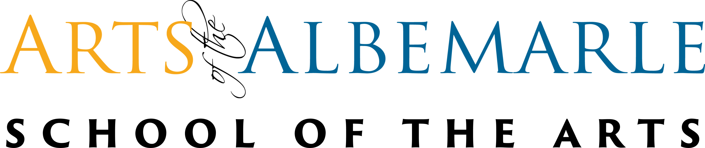
Frequently Asked Questions

Class Locations
Where are the classes held?
-Classes at AOA School of the Arts will be held in three locations, two of the three are in the Arts of the Albemarle main building (516 E. Main St.) The Maguire Theatre located on the 2nd floor and The Twiford Room located on the 3rd floor. The third location being the Madrin Studio (115 N. Poindexter St.) across from Big Boss Burrito.

Are there multiple locations for classes, and if so, how can I find out the specific location for my child's class?
-Please refer to the website or registration packet for class schedule and location. Classes have been given a designated space that will remain through the semester. If there is a location change, you will be contacted before that class starts.

Is there any additional information about the facilities where classes are conducted?
-Remember, that this is a space to learn and grow within your creativity. We want to ensure a clean space for students and staff. Spaces at Arts of the Albemarle are also used for rentals and AOA patrons, so make sure you are keeping these spaces presentable.

Class Schedule
How long is the AOA School of the Arts spring semester?
-Spring classes begin the week of February 12, 2024 through the week of April 25, 2023.

What time does my child's class start and end?
-Your child’s class schedule start and end time will be detailed in the schedule on the website, registration packet or document picked up at open house.

Is there a specific time for pick up and drop off related to the class schedule?
-We ask that parents/guardians arrive 10 minutes before their child’s last class ends. If your child is in any other program within AOA or AOA School of the Arts that ends later than classes, plan to pick them up once that program is complete.

Will there be an End ofS emester performance?
-Yes. There will be a free performance for family and friends on Thursday, April 25th, 2024 at 6:30pm.

Will students have spring break off?
-Yes.S tudents will have spring break off from April 1st-April 5th ,2024.

Materials for Class
What does my child need to bring for their classes?
-With AOA School of the Arts offering classes of many varieties, there are specific items that may need to be acquired based on class type. Those things will be specified during open house for whichever class you choose. In general, we recommend that students bring a water bottle and clothes you can move in.

Are there any specific dress codes or supply requirements?
-At AOA School of the Arts, we request that students arrive for class in comfortable, movable clothing. Please refrain from wearing jeans, restricting clothing, uncomfortable footwear, or short skirts and dresses (unless worn with bike shorts or the appropriate layers for movability).

Class Enrollment:
How late in a semester can a child enroll in a class?
-Enrollment for the Spring 2023 semester at AOA School of the Arts will remain open until February 19th, 2024.
Note: Classes begin February 12, 2024.

Is there a specific enrollment period, or can students join at any time during the semester?
-The enrollment period for AOA School of the Arts opens on January 5, 2024, and closes on February 19th, 2024. Any student looking to enroll after the closing date should plan to enroll in the school for the following semester.

Are School of the Arts classes different than the Center Players? Does my child have to participate in both?
-The School of the Arts operates separately from Center Players, though it is highly recommended that students who wish to participate in a main stage production are also enrolled in SOA classes—especially musical theatre, acting, and voice. Students of AOA School of the Arts are not required to participate in Center Players, nor are you required to be enrolled in School of the Arts classes in order to audition for the Center Players production.

How many classes can I enroll in during registration?
-You have the freedom to enroll in as many as one or all classes. We highly recommend enrolling in dance, acting and voice, especially if you are planning to audition for a Center Players production.

Supervision/Spaces for In Between Classes and Rehearsals:
What supervision is provided for students in between classes and rehearsals?
-We ensure that your child is under the supervision of our entrusted instructors from the time of drop off to the time of pick up. If your child has a class in another building the instructor will wait until all belongings are gathered and will walk the group over to their next class.

Drop Off/Pick Up Procedures:
How does drop off and pick up work for students?
-For classes in the Twiford Room or Maguire Theater, please use the main entrance for drop off/pick-up at 516 E. Main Street. For classes held in the Madrin Studio (on Poindexter St. across from Big Boss Burrito), students can be dropped off directly. Parents are responsible for ensuring their child makes it into the building upon drop off and instructors will supervise pickup. If your child is being picked up by someone not on their registration papers, please notify your instructor.

